NAME:Rishik JK
REG.NO :192511052

CSA1708-ARTIFICIAL INTELLIGENCE
LAB EXPERIMENTS

Program 2 : Python Program to Solve 8. Queen Problem

AIM:
To write a Python program to solve the 8-Queen Problem using the Backtracking algorithm.

ALGORITHM
- Start with an empty 8 × 8 chessboard.
- Place a queen in the first column.
- Check whether the position is safe.
- A position is safe if no other queen is present in the same row or diagonal.
- If safe, place the queen and move to the next column.
- If no safe position is available, backtrack and change the previous queen's position.
- Repeat until all 8 queens are placed.
- Display the final chessboard.

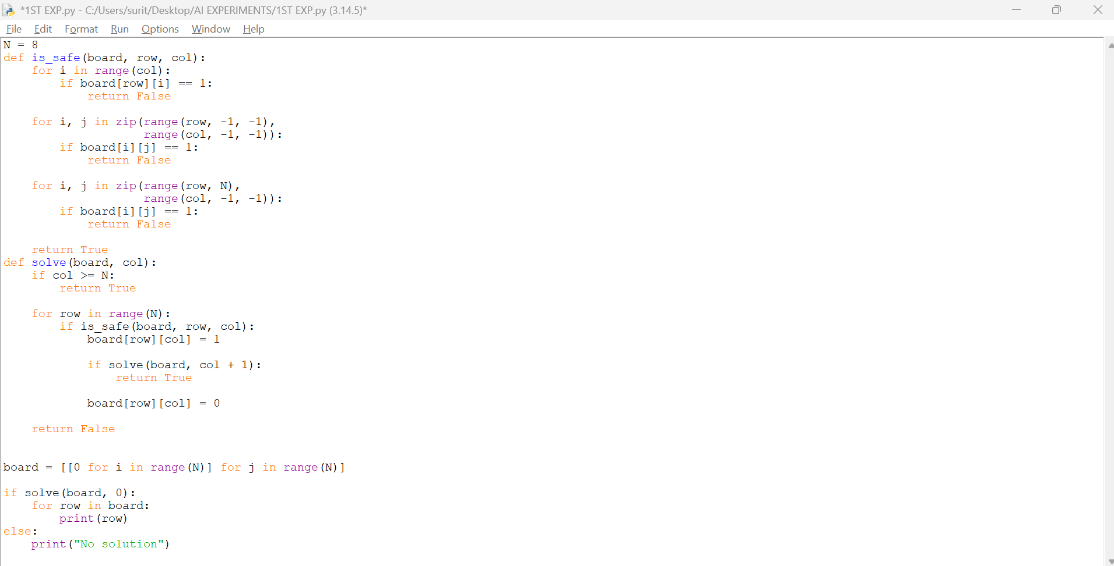

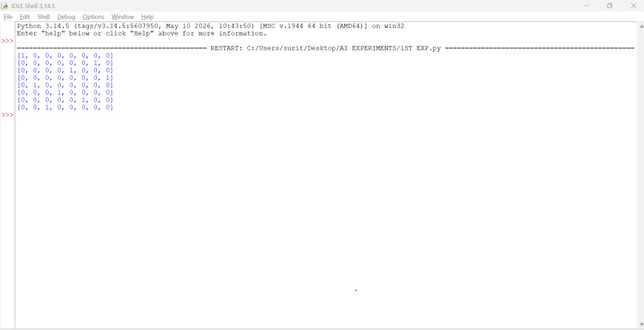

RESULT: Thus, the 8-Queen Problem was successfully solved using the Backtracking algorithm in Python.

